Workflow Details

Manual Access Request

Workflow Details
Attribute | Value
Workflow Name | Voyager AccessRequest LCM Provisioning
Workflow Type | LCMProvisioning

Workflow Key Variables
Variable Name | Variable Value
approvalScheme | manager, owner
approvalMode | serial
policyScheme | interactive
approvalSplitPoint | owner

Flow Chart
Voyager AccessRequest LCM Provisioning

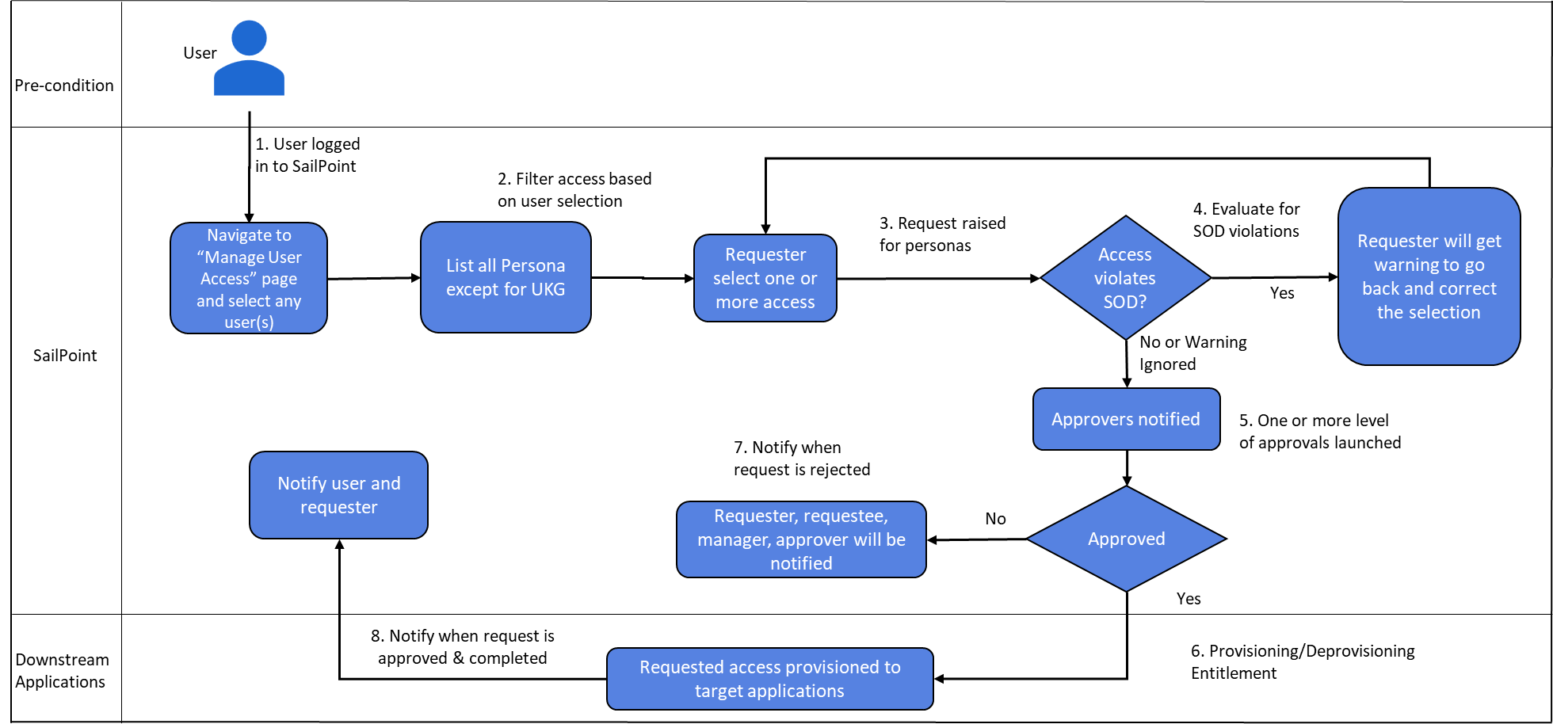

Flow Steps Descriptions:

- An active user logs in to SailPoint IIQ platform, is able to access the “Manage User Access” link and can select any user to request access.
- All available and requestable roles and entitlements are listed on the access selection page to request or already provisioned access can be requested to get removed. On this page, birthright personas are not shown.
- Before the submission of request, workflow performs SOD policy evaluation to check if accesses being requested does not result in any SOD policy violations.
If the system detects any potential policy violation then the requester is alerted on the screen and advised to make corrections in selected access.
Here, the requester has the option to correct the selection or ignore the violation and submit the request.
- Requester submits the access request.
- The approval level and approvers are calculated by the workflow on the basis of requested accesses and notify them over email. Based on the approval levels, all approvals happen in serial mode and the first approver that rejects terminates the entire approval.
- The approvers can approve or reject the request by logging into SailPoint IIQ platform.
- In case of rejection, the requester, requestee, manager and the approver are notified of the access request being rejected.
- In case of request getting approved from all the approvers, the requested access is provisioned on the target applications.
- If there are any failures during access provisioning on the target systems, a Service Incident is created.
- Once the access is provisioned successfully, the requester and the user are notified over email.

Step Summary

Voyager AccessRequest LCM Provisioning Workflow – Step Summary
Step No. | Workflow Step | Description
1 | Start | Start of the Voyager Access Request LCM Provisioning
2 | Initialize | Call the standard subprocess to initialize the request, this includes auditing, building the approvalset, compiling the plan into project and checking policy violations.
3 | Exit On Manual Work Items | Out of the box LCM Provisioning Workflow step
4 | Exit On Provisioning Form | Out of the box LCM Provisioning Workflow step
5 | Exit On Policy Violation | Out of the box LCM Provisioning Workflow step
6 | Create Ticket | Call a subprocess to create a ticket in the ticketManagementApplication is non-null.You can specify a specific 'ticketDataGenerationRule' here or you can also specify it on the application. It'll be read from the argument first and fall back to the application config.
7 | Pre Split Approve | Call to our standard subprocess to handle the default approvals for manager, owner and security officer. In place of the OOTB subprocess, a custom workflow ‘Voyager AccessRequest Provisioning Approval Subprocess’ is used.  Workflow - Voyager AccessRequest Provisioning Approval Subprocess  Description - The OOTB subprocess has been updated with  - The after script modification to mark the work item as rejected in case of work item expiry.  - The interceptor script is updated to set the work item expiration to 21 days.  - The reminder notification frequency is set to every 7 days.
8 | Examine Plan Before Split | This step is used to debug and log the provisioning plan.
9 | Split Plan | Step to split the provisioning project into individual projects for each item requested.This will only run if the approvalSplitPoint is configured.
10 | Approve and Provision Split | Call the Approve and Provision Subprocess for each Provisioning Project generated in the Split Plan step.  In place of the OOTB Approve and Provision Subprocess, a custom subprocess ‘Voyager AccessRequest Approve and Provision Subprocess - Split Plan’ is used.  Workflow - Voyager AccessRequest Approve and Provision Subprocess - Split Plan  Description - The OOTB subprocess has been updated with calling a custom subprocess ‘Voyager AccessRequest Provisioning Approval Subprocess’ in place of the OOTB Provisioning Approval Subprocess.  Workflow - Voyager AccessRequest Provisioning Approval Subprocess  Description - The OOTB subprocess has been updated with  - The after script modification to mark the work item as rejected in case of work item expiry.  - The interceptor script is updated to set the work item expiration to 21 days.  - The reminder notification frequency is set to every 7 days.
11 | Assimilate Splits | Assimilate all projects returned from the split into the global project.
12 | Approve and Provision | Finish any remaining approvals and provision.
13 | Refresh Identity | Add arguments as necessary to enable refresh features. Typically you only want this to correlate roles. Don't ask for provisioning since that can result in provisioning policies that need to be presented and it's too late for that. This is only to get role detection and exception entitlements in the cube.
14 | Notify | Call the standard subprocess that will notify the various actors based on the notification scheme.
15 | Check Provisioning Status | This step verifies whether the requested application account has been provisioned successfully or not and calls a custom subprocess to create Service Now incident in case of any provisioning failure.  Workflow - Voyager SNOW Failure Workflow  Description -  - This subprocess is used to create the SNOW incident in case of any provisioning failure.  - The application for which the provisioning has failed is also calculated and added to the incident description.  - Additionally, the identity request is also updated with the incident details in order to view the incident number from Access Requests UI.
16 | Finalize | Call the standard subprocess that can audit/finalize the request.
17 | end | Ends the workflow after completing provisioning, auditing, and notification activities.

Workflow Description

Workflow:

Name : Voyager AccessRequest LCM Provisioning

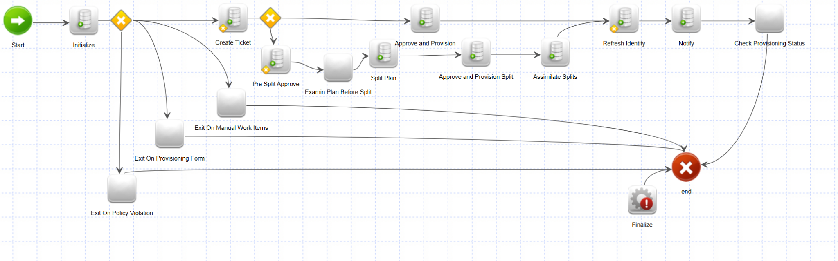

1. Start
- Start of the workflow.

2. Initialize
Calls the standard subprocess ‘Identity Request Initialize’ to initialize the request, this includes auditing, building the approvalset, compiling the plan into project and checking policy violations.

3. Exit On Manual Work Items
Out of the box LCM Provisioning Workflow step.

4. Exit On Provisioning Form
Out of the box LCM Provisioning Workflow step.

5. Exit On Policy Violation
Out of the box LCM Provisioning Workflow step.

6. Create Ticket
Out of the box LCM Provisioning Workflow step to call a subprocess to create a ticket in the ticketManagementApplication.

7. Pre Split Approve
Call to our custom subprocess ‘Voyager AccessRequest Provisioning Approval Subprocess‘ to handle the approvals for manager, owner and security officer.

- “Approval” step of the “Voyager AccessRequest Provisioning Approval Subprocess” has been updated/customized to handle the required reminders frequency and request cancellation if approvals are not completed in time.
- The after script modification to mark the work item as rejected in case of work item expiry.
- The interceptor script is updated to set the work item expiration to 21 days.
- The reminder notification frequency is set to every 7 days.

8. Examine Plan Before Split
This step is used for debugging and logging of the provisioning plan.

9. Split Plan
This is an out of the box step of “LCM Provisioning” workflow without any customization. This step uses the approvalScheme and approvalSplitPoint variables to split the requested items into sub-plans.

10. Approve and Provision Split
Calls the custom subprocess ‘Voyager AccessRequest Approve and Provision Subprocess - Split Plan’ for each Provisioning Project generated in the Split Plan step.
This step has reference to the primary approval assignment rule “Voyager AccessRequest Approval Assignment Rule” to handle custom approvals creation.
Voyager AccessRequest Approval Assignment Rule:
- This rule examines the requested items and determines if the request is made for an entitlement or role.
- Once the requested object type is identified then it extract following two attributes from either ManagedAttribute object or Bundle object:
  - approval_levels : This attribute is a common custom attribute with ManagedAttribute and Bundle and it contains one of the three possible approval schemes ("manager" or “manager,owner” or “manager,owner,securityOfficer”).
  - security_officer_name : This is also a common custom attribute for ManagedAttribute and Bundle. It contains the identity name for the security officer.
- The rule examines the fetched attributes values, remove the manager approval from the scheme since manager approval is already completed, and then creates approval items.
- A final approval list is returned from the rule.
Voyager AccessRequest Approve and Provision Subprocess - Split Plan:
- This sub-process has all the out of the box steps of the “Approve and Provision Subprocess” except the following customizations.
- The “Approved” step is updated to referrer the sub-process “Voyager AccessRequest Provisioning Approval Subprocess”. This sub-process has AfterScript and InterceptorScript to handle the reminders and request cancellation.

11. Assimilate Splits
Out of the box LCM Provisioning Workflow step. Step is used to assimilate all projects returned from the split into the global project.

12. Approve and Provision
- Out of the box LCM Provisioning Workflow step.
- Calls the ‘Approve and Provision Subprocess’ to finish any remaining approvals and provisioning.

13. Refresh Identity
- Out of the box LCM Provisioning Workflow step.
- This step can be used to refresh the identities being updated.

14. Notify
- Out of the box LCM Provisioning Workflow step.
- Calls the ‘Identity Request Notify’ subprocess that will notify the various actors based on notification scheme.

15. Check Provisioning Status
‘Voyager SNOW Failure Workflow’ subprocess is called from this step to create a SNOW incident in case of any provisioning failures.

16. Finalize
Out of the box LCM Provisioning Workflow step. Calls the ‘Identity Request Finalize Sub Process’ to audit/finalize the request.

17. Stop
The workflow ends after completing all provisioning, auditing, and notification activities.

